# 

# Kinematics: How to Describe Motion

## 

## 

## 

## The word *“kinematics”* comes from a Greek word *“kinesis” meaning motion,* and is related to other English words such as *“cinema” (movies) and “kinesiology”* (the study of human motion).

“Kinematics is the set of ***linguistic***and ***mathematical*** methods used to describe 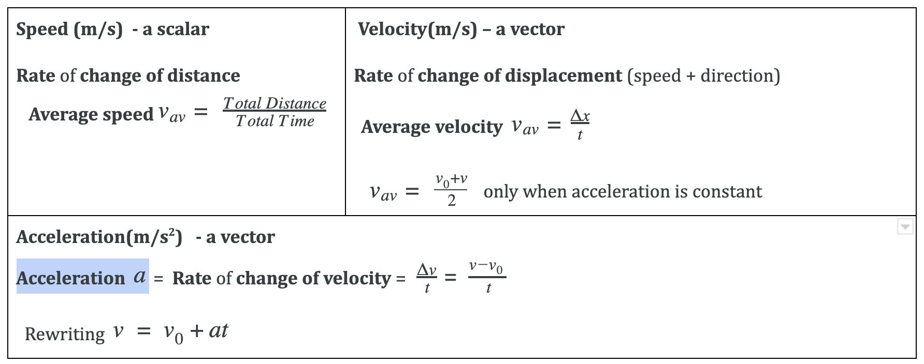motion”

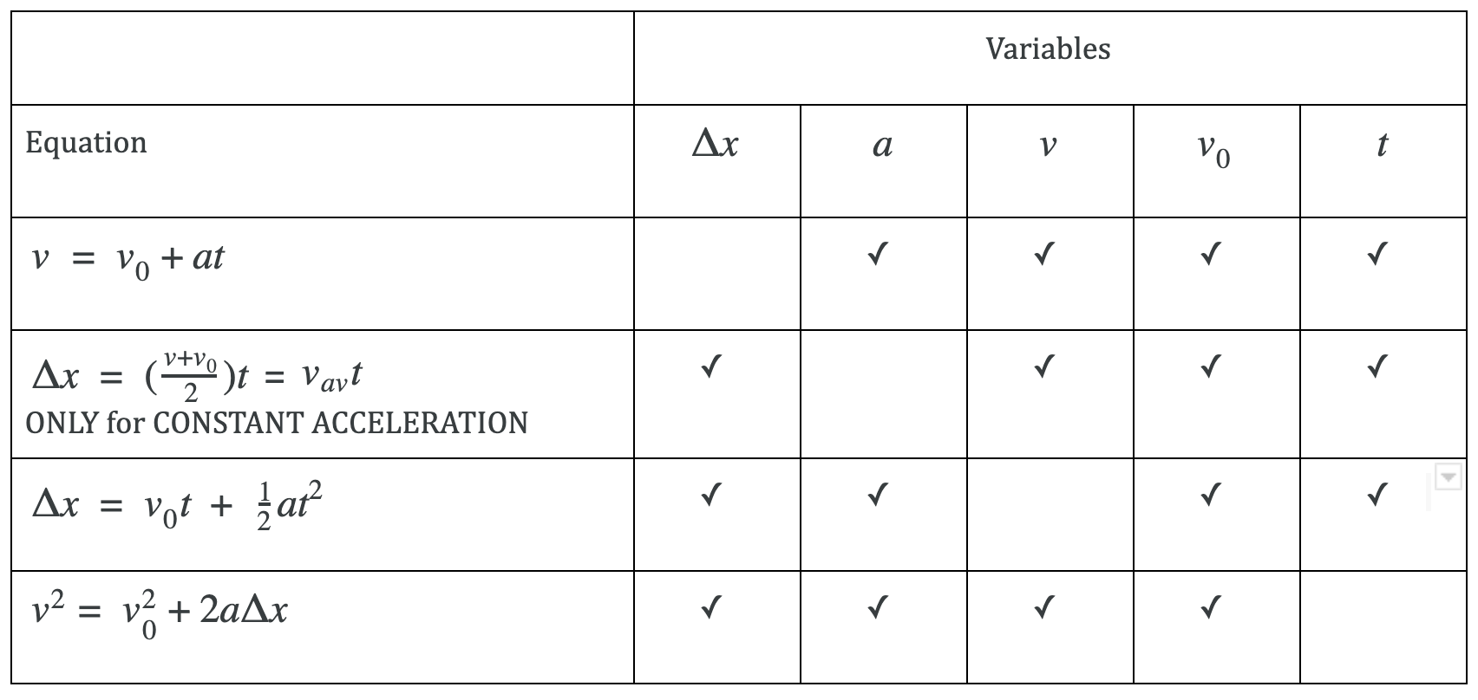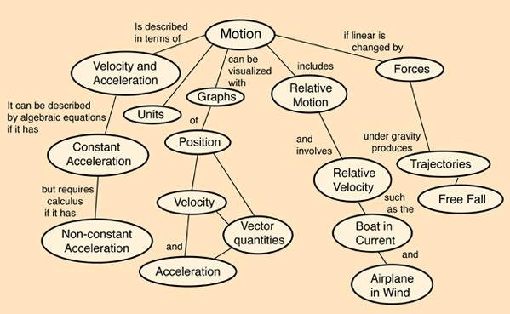

## 

## 

## Unit 1: Learning Targets

|  |  |  |  |
| --- | --- | --- | --- |
| **Learning Targets**  ***I CAN…*** | **Huh!** | **I sort of get it** | **I totally get it** |
| * describe motion in **Words** – such as change, rate, physical quantity, displacement, speed, velocity, acceleration, average velocity, instantaneous velocity etc. etc. |  |  |  |
| * describe motion in **Graphs** |  |  |  |
| * describe motion in **Equations** |  |  |  |
| * describe motion with **Diagrams** |  |  |  |
| * **decode** a scenario and extract the **given physical quantities and the unknown physical quantity; translate the givens and unknowns into algebraic representations** |  |  |  |
| * **pattern check** the givens and unknowns and **identify the correct equation/s**  that will help solve the problem |  |  |  |
| * symbolically solve for the unknown by **manipulating equations and graphs** |  |  |  |
| * give the final answer with the **correct units and significant figures.** |  |  |  |
| * explain when an object is in **Free Fall** and when it is NOT |  |  |  |
| * apply the equations of motion for **motion in the vertical direction** |  |  |  |
| * predict the **effects of acceleration due to gravity** on an object **dropped/thrown** into air |  |  |  |
| * **explain graphs of motion**, including position, velocity and acceleration graphs, |  |  |  |
| * **predict the shape of graphs** given a scenario |  |  |  |
| * **relate or translate** between **position, velocity, and acceleration graphs** of **motion in 1D** with respect to time. |  |  |  |

## Introduction to Physics Big Ideas & Science Practices

Have you ever wondered what it would be like to live in outer space? That question, at first glance, may seem to be only for astronauts and star trek geeks, but really we are all living in outer space. **Our earth is moving through space and in doing so, it follows some rules. The physical universe is fascinating and space travel will definitely become a reality in your lifetime.**

Back on earth, have you ever wondered what it would feel like to be struck by lightning? Maybe not, but maybe you’ve wondered how to avoid getting struck by lightning! Lightning too, does not, it turns out, strike at random. It also follows some rules. How about understanding if cell phones using 5G wireless protocols are safe. What are the rules governing electromagnetic radiation?  **Is all radiation bad?**

And think about…Gravity. A force that you know so well. It dominates your life here on earth. But have you ever wondered how it works? What it is? You know that it is gravity that causes Wile E. Coyote to fall to the ground while chasing Road Runner, although the animators take brief liberties with the laws of gravity for comical effect. Do animators and artists need to understand some of the fundamental laws of physics? Absolutely if they have to recreate Baby Groot’s dance moves realistically we have to do so within the confines of the laws of Physics. To quote, Charles Martin Jones, an American animated filmmaker and cartoonist, **“We must all start with the believable. That is the essence of our craft.”** So timing, spacing, scaling, and predicting how things move is the first step in realistic animation.

So, if you haven’t guessed already, physics is about rules. **Physics is the study of the fundamental rules that govern the way the universe works.** It is the foundation upon which all of the other sciences are built.. The beauty of physics lies in the simplicity of these rules. The job of a physicist is to figure out these rules. How do we do that? **Let’s do a thought experiment…….**

*Do any of you play chess? Imagine you are observing a game, like chess. Your task is to figure out the rules of the game, simply by watching it. Read Nobel-Prize winning Physicist Leon Lederman’s metaphor of an invisible soccer ball to explain how scientists look for the “God Particle.” In fact the article makes a case that as responsible citizens we should always be looking for* ***Invisible Soccer Balls.***

**How do we figure out the rules obeyed by phenomena in the physical universe? The skills that allow us to determine/understand the rules of Science are called 7 Science Practices. They are attached in Appendix A.** This course will help you develop and hone science practices whilst grappling with the Physics content grouped into **7 Big Ideas (attached in Appendix B).**

These Science Practice skills help us **interpret COVID data** in a pandemic era, ask the right questions and take the right precautions as concerned and caring citizens. They help us **dissect news articles** looking for the veracity of sources and evaluating multiple perspectives because each of them leave out different strategic elements. These skills help us **build economic models** or understand them as we plan our own savings. Our ability to look at a situation from **multiple points of view (What happened to the gasoline cartoon**[1] **)**, is vital to creating an **empathetic, caring, and resourceful citizenry** (The disasters are collaborating better than we are cartoon[2] ) .

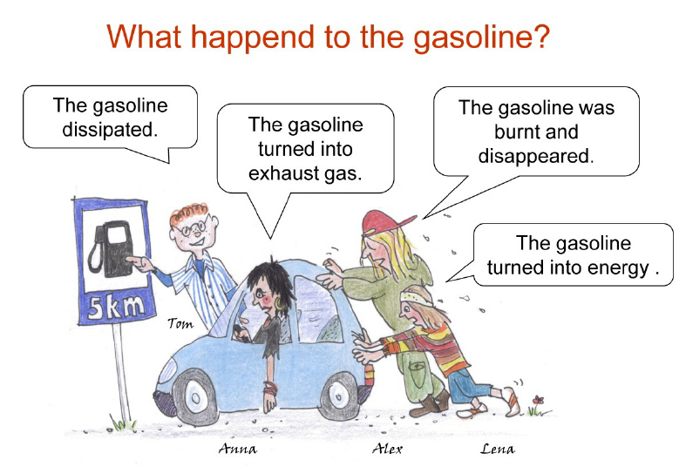

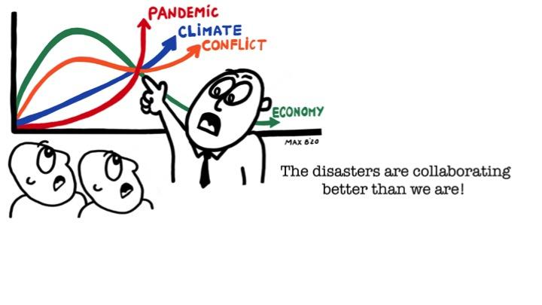

One of the Science Practices that we are going to start practicing with is to describe an idea in Physics using a variety of models or representations or language if you will. For example, motion in kinematics can be described 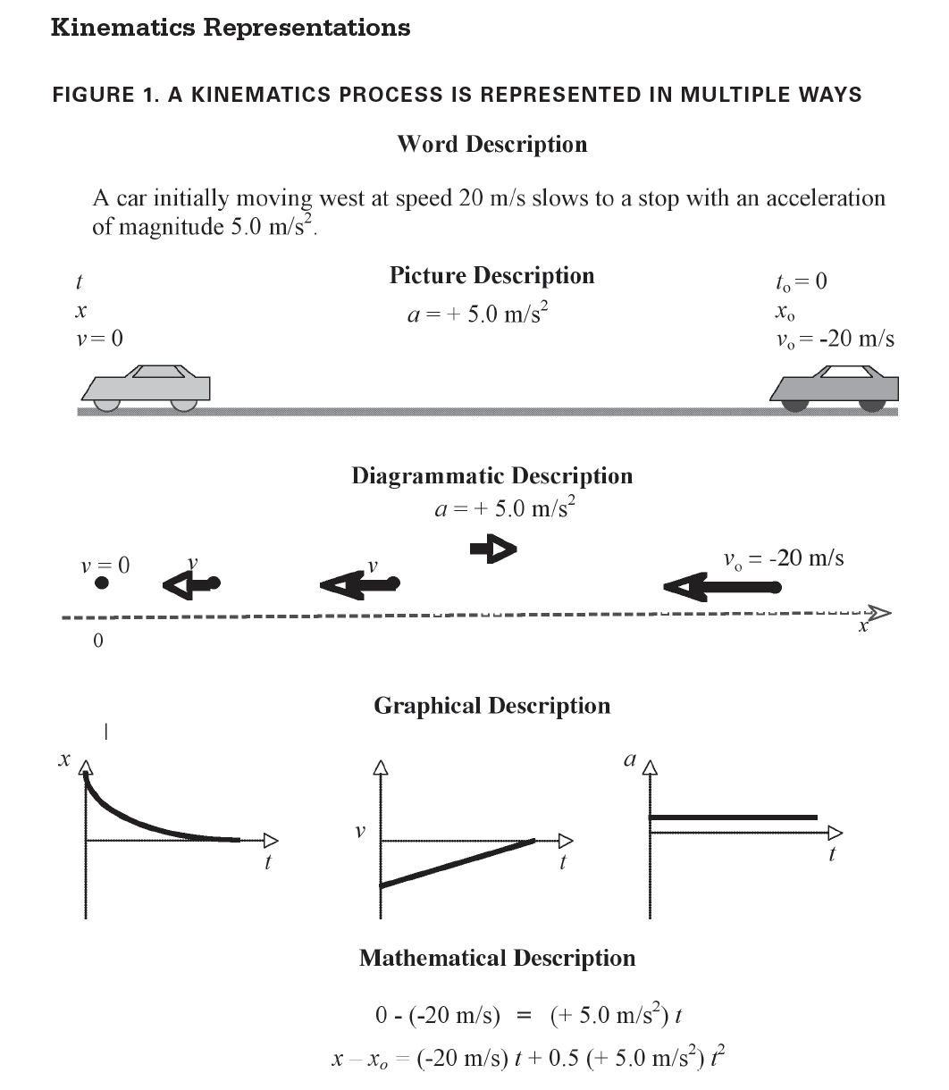using multiple representations such as

* Words
* Diagrams
* Graphs
* Algebraic Equations
* Data Tables

**A good understanding of the universe requires us to be able to describe this world in multiple representations and translate from one representation to another.**

For example, the figure here shows Kinematics Representations[3].

We start our description of motion with words; **words that are defined very precisely.** In this first unit you will learn the definitions of some very important words such as

1. Physical Quantity
2. Change
3. Rate
4. Position,
5. Displacement etc. These words will be highlighted when you first encounter them.

**Make sure to understand the unique definitions of the words in the context of Physics.**  **The precise definition then allows you to translate the definition into graphs, equations, diagrams etc…**.Whilst mathematical representations are important and powerful, a common pitfall is to ignore the word and pictorial representations which become a handicap in your ability to visualize a scenario and fully understand and decode it. A lot of Math with no conceptual understanding can obscure the Physics and your learning. So **focus on all representations and the ability to translate between them.** That is powerful!

## [The New York Times and the Invisible Soccer Ball](http://www.dailykos.com/story/2008/04/21/499466/-The-New-York-Times-and-the-Invisible-Soccer-Ball)

Mon Apr 21, 2008 at 06:52 AM PDT

Nobel Prize-winning physicist Leon Lederman coined the metaphor of The Invisible Soccer Ball in his 1993 book [*The God Particle: If the Universe is the Answer, What is the Question?*](http://www.amazon.com/God-Particle-Universe-Answer-Question/dp/0385312113) Lederman used the metaphor to explain how particle physicists examine a problem.

Lederman asks us to imagine a race of aliens whose eyes cannot see a soccer ball, and to imagine taking such an alien to a soccer match. Because the alien can't see there is a ball, the action on the pitch would seem bizarre: as if the players were running about randomly, often kicking at each other's feet but rarely making contact, until for some unseen reason half of the players jump with ecstacy and the crowd roars with approval or dismay.

But, Lederman says, if the alien were to watch closely, a pattern would begin to emerge. The alien would realize the players were all looking at something. That something moved around on the pitch. And the players weren't kicking at each other's feet after all, but at that invisible something. If the alien watched very closely, he would notice that, just before half of the players jump with ecstacy and the crowd roars, there was a momentary round bulge in the back of the net. The alien would deduce that there must be a ball on the pitch - even if he can't see it - and that the players are kicking it about, attempting to get it into the nets at either end. He could even tell the size of the ball, by the bulge it makes when it hits the net. And, once he knew there must be a ball, he could estimate its location by watching the players' reactions to it.

This, Lederman said, was the method of a particle physicist. I suggest it should also be the method of the news consumer: we should always be alert to the existence of Invisible Soccer Balls.

Often the media narrative is inadequate to explain events. It is as if they are broadcasters at a World Cup match, talking about the action on the pitch, *without showing or even mentioning the ball*. The announcer gives us a moment-by-moment account. The commentator gives us strategic and tactical insights. Yet we still can't quite make sense of what we're seeing. *Something - something important - is missing*.

When this happens, we tend to chalk it up to bad players. After all, if we can understand the strategies and tactics the commentator described, then why can't the players - professionals all - perform them? Either the players are incompetent, or the match is rigged. Or …

... there's something else involved in the game, something key to the action that the media aren't showing or mentioning. There's an Invisible Soccer Ball.

**This is not an argument for conspiracy theories.** They tend to be far too elaborate. They assume dozens if not thousands of actors flawlessly performing a secret script ... without rehearsal ... and without leaving any traces of the script lying about. Anyone who's ever tried to organize a school play could point out the absurdities.

**This is an argument for incomplete information.** Often the media are stuck reporting what they've been told, knowing they haven't been told everything, but also knowing they can't easily get to the missing bits. Or they leave bits out. There are several reasons for this:

**Mythology**. Breaking coverage of tragedy tends to be woefully inaccurate. The reporters may be caught up in the events themselves, or can't yet fact-check reports coming in. This tends to yield mythic stories of horror or heroism, from the tales of rape and murder in the Superdome after Hurricane Katrina to the glorious but fictitious battle of Jessica Lynch in Iraq.

**Secrecy**. Coverage of ongoing military operations , police investigations, or diplomatic negotiations are often only marginally accurate. The reporters know they're not being told - or may be asked not to reveal - vital information that someone thinks might compromise the events in progress. Sometimes the secrecy is justified, and sometimes not.

**Complexity**. This is often the case with science and economic coverage. The media too often assume we lack the intelligence or patience to sort out complex processes. So we get Event McNuggets, bite-sized factoids that may be "true," but tell as little of the actual process as a McNugget tells us about the biology of a chicken.

**Ratings**. The real actors and motives might seem too prosaic, too boring, so the media "sex up" the story with more dramatic actors and motives, even if the more dramatic tale has little or no resemblance or relevance to the actual events. This is often the case with political coverage.

**Reputation**. This was the case with the *New York Times* piece about military analysts. The media want us to see them as independent - as our eyes and ears - rather than as government or corporate mouthpieces. They want us to believe they go to the places we can't or won't, and tell us the things we couldn't easily find out on our own. To the extent we believe that, we rely on them, provide an audience for their advertisers, and keep them profitably employed. But of course, the media do rely on "insider" sources, people who are connected to the people, institutions, and events they are "analyzing." And of course the analysis is biased by their need to maintain those connections.

When the media narrative doesn't match events, when the explanation is inadequate, we have to ask ourselves what's missing. Like a particle physicist, we have to study what we *can* see, ask what missing pieces would most simply complete the puzzle, then look for evidence of those missing pieces. In the Internet Age - giving us easy access to newspapers, magazines, academic journals, biographical data, and even first-hand reports from around the world - we often can do this fact- and source-checking for ourselves. And we should.

Rather than assuming the game is chaotic because the players are bad - incompetent or bought off - we should ask ourselves why *good* players would do what they're doing. We should ask ourselves what we can't see.

**We should look for Invisible Soccer Balls.**

## Word Representation & Translation to Mathematical Representation

##### Refer to section 2.1-2.3, p. 27-34, in C&J Physics

### What is the difference between **distance** traveled by a person and the **displacement** of a person?

### What is the difference between **speed** and **velocity**?

### What is the meaning of the word **“rate”** often used in Physics definitions?

### What is the meaning of the word **“ change”** as it is used in Physics?

### What is the difference between a **vector** and a **scalar**? Give an example of each.

### What is the difference between **average** velocity and **instantaneous** velocity?

### What is the difference between a **constant velocity** motion and a **changing or variable velocity** motion? Give an example of each.

### In what ways can an object change its **velocity**?

### What is the difference between **velocity** and **acceleration**?

### In what ways can an object **change its acceleration**?

### What is the difference between a **constant acceleration** and a variable **acceleration**?

### Give an example of an object with a…

#### **Positive velocity** and **negative acceleration**

#### **Negative velocity** and **negative acceleration**

#### **Positive distance** and **negative displacement**

### What is a **physical quantity?** What are the different ways to talk about a physical quantity? What are the possible **attributes of a physical quantity**?

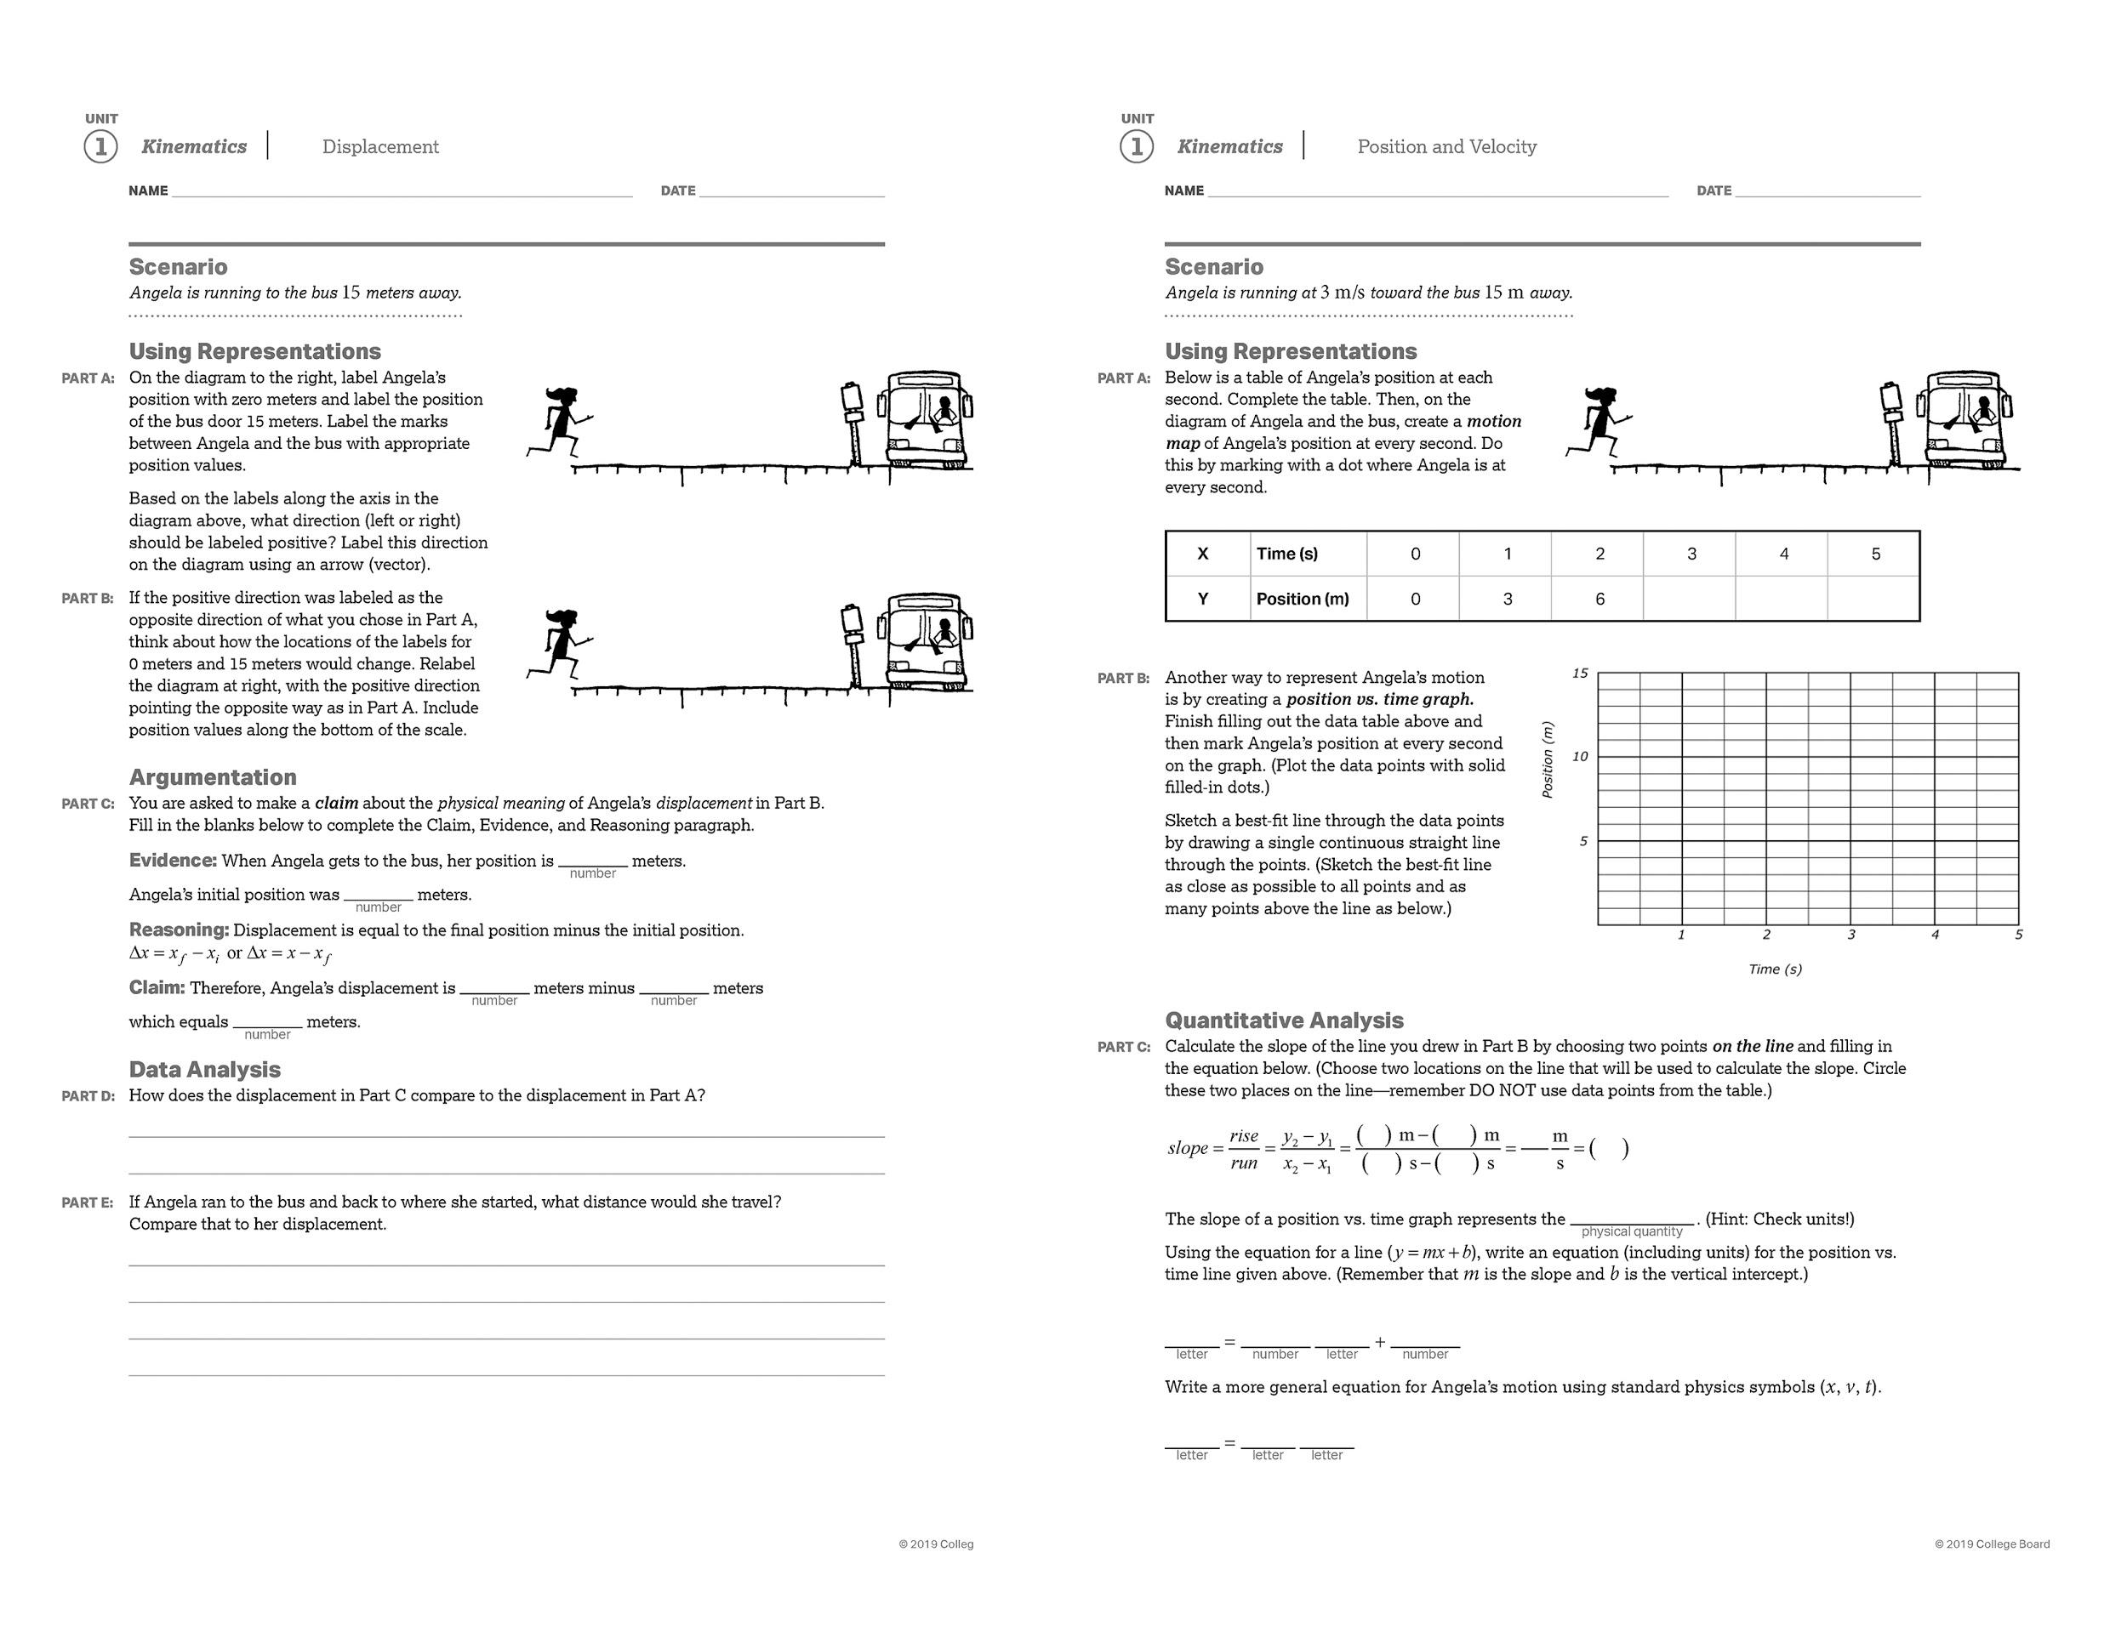

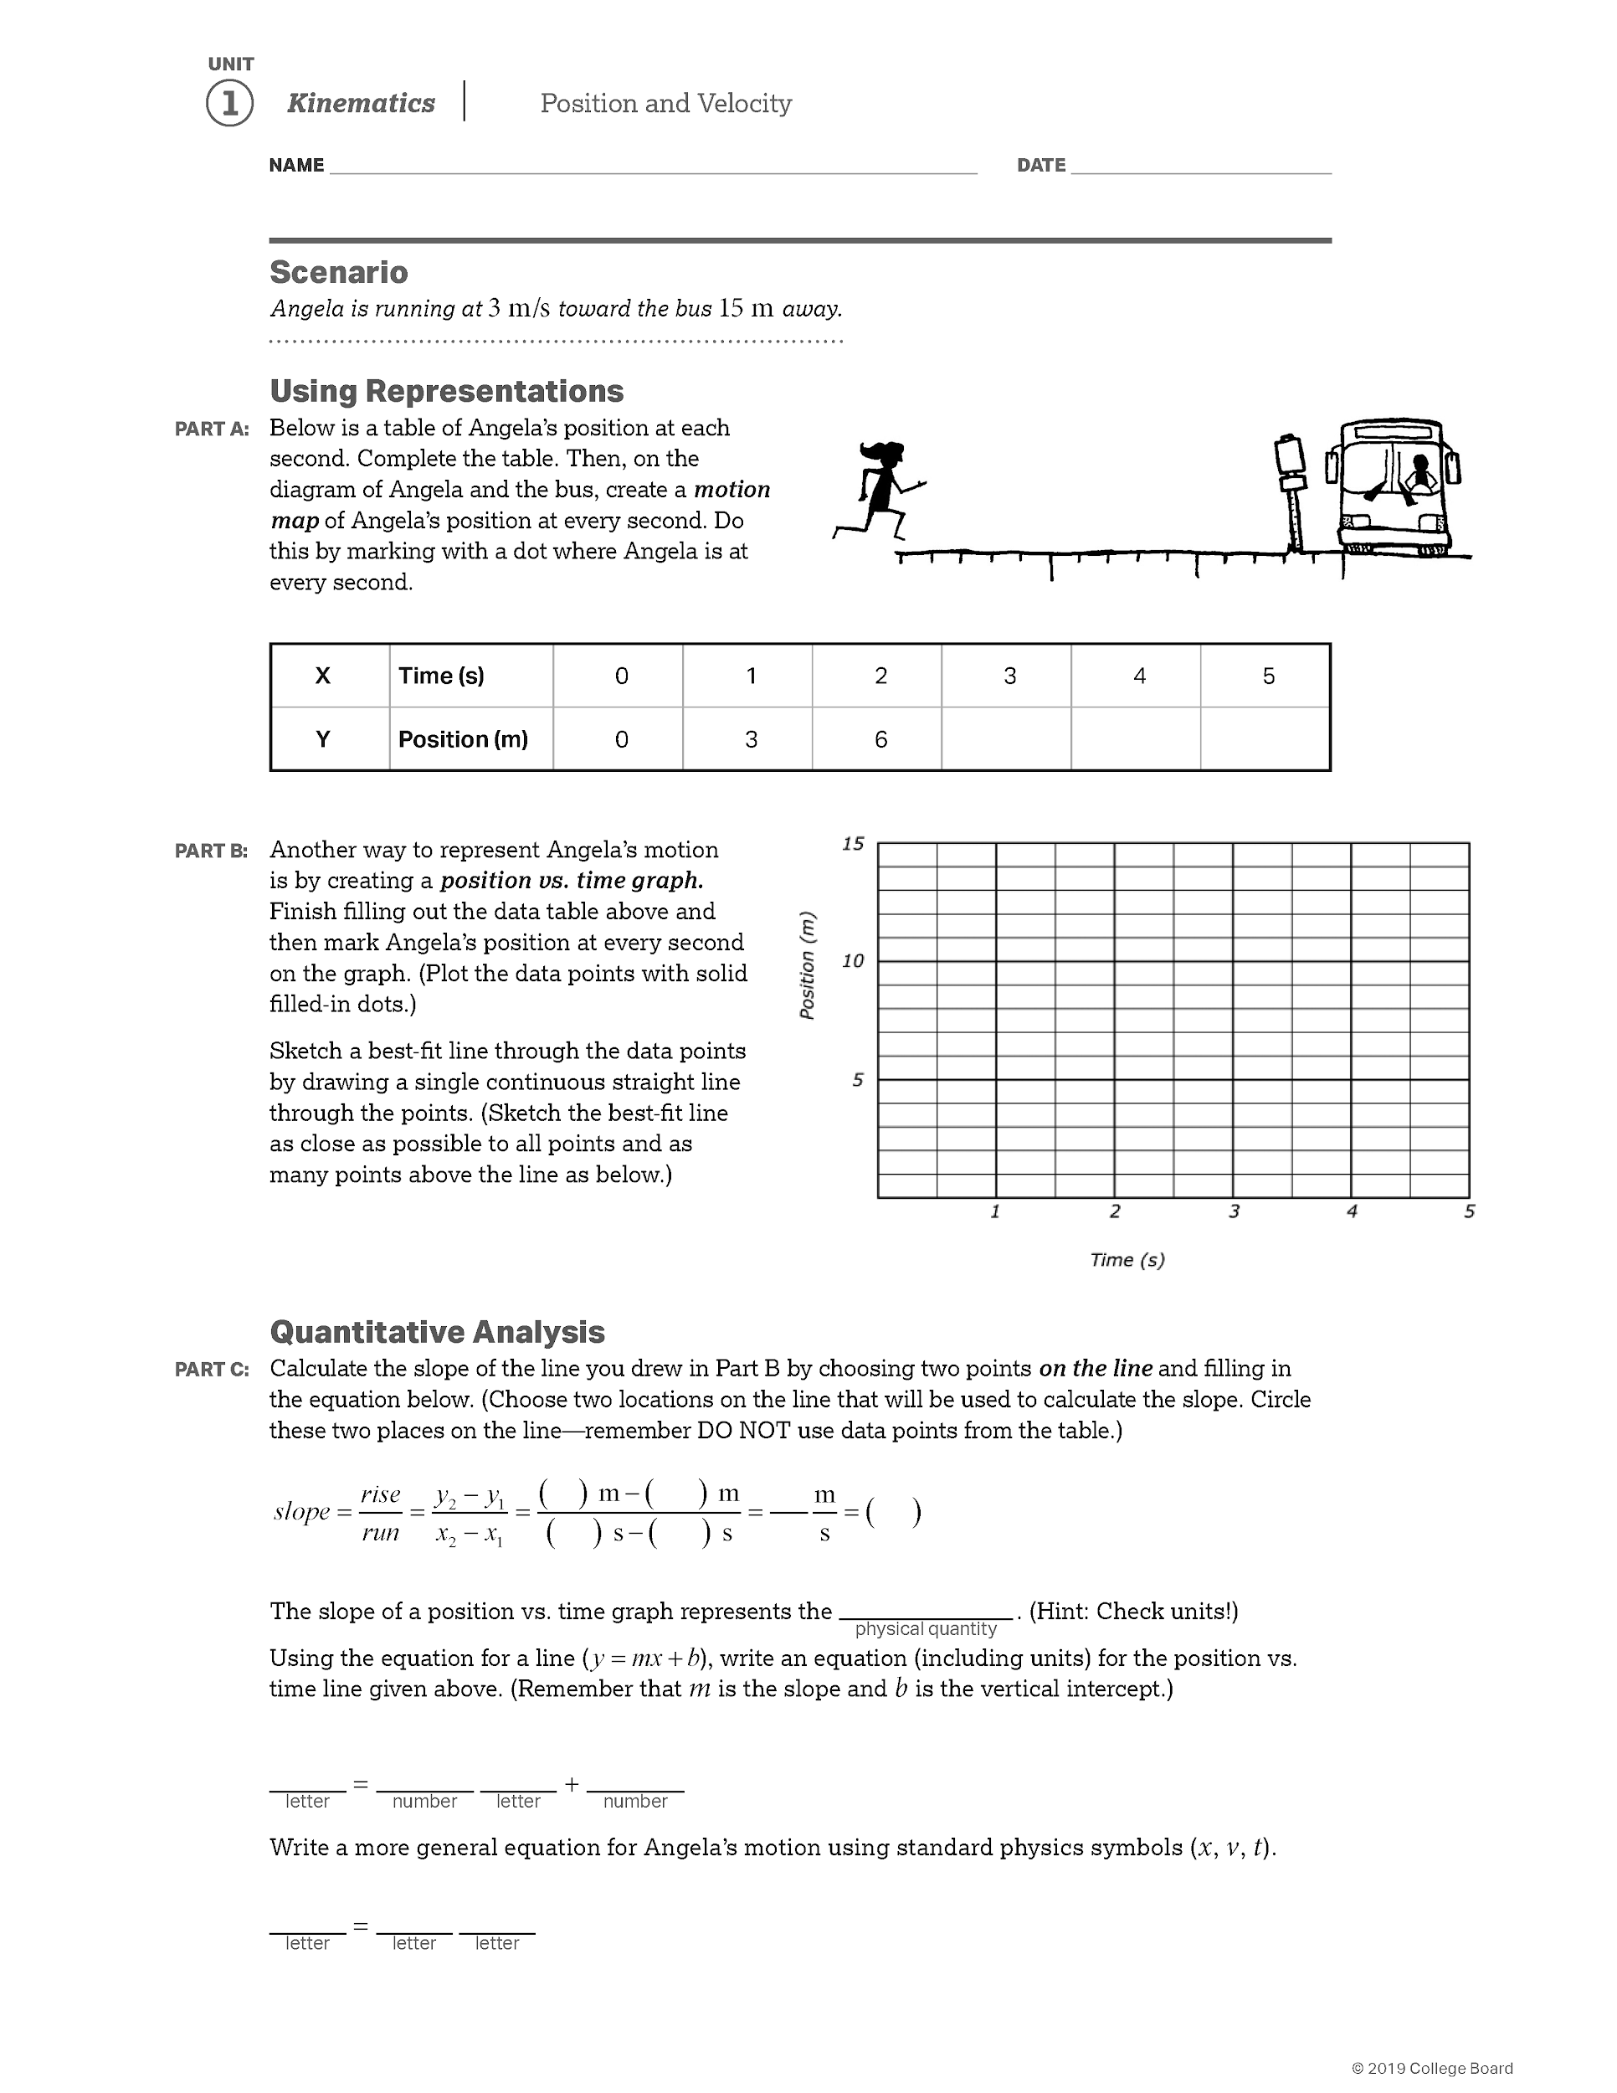

## 

## 

## 

## Equations of Motion for Constant Acceleration

1. Rate = divided by time

2. Change = Final – Initial (of anything such as position, speed, velocity etc.)

3. Distance: how far something travels – Scalar quantity

4. Displacement: how far something travels in a given direction - $Δx = {x - x_{0}}_{}$ = initial position-final position

5. Time = t

|  |  |
| --- | --- |
| **Speed (m/s) - a scalar**    **Rate** of **change of distance**    **Average speed $v_{av}= \frac{Total Distance}{Total Time}$** | **Velocity(m/s) – a vector**  **Rate** of **change of displacement** (speed + direction)  **Average velocity $v_{av}=\frac{Δx}{t}$ $v_{av}= \frac{v_{0}+v}{2}$**    only when acceleration is constant |
| **Acceleration(m/s2) - a vector**  **Acceleration $a$** =  **Rate** of **change of velocity** = $\frac{Δv}{t}$ = $\frac{{v-v_{0}}_{}}{t}$   Rewriting | |

1. Final Velocity =

2. Initial Velocity =

3. Acceleration =

4. Speed is the magnitude of the velocity vector. Hence the symbol for speed is

Hence there are 5 kinematic variables: *x, v, v0, t,* and *a*

|  |  |  |  |  |  |
| --- | --- | --- | --- | --- | --- |
|  | **Variables** | | | | |
| **Equations** | $Δx$ | $a$ | $v$ | $v_{0}$ | $t$ |
| $v = v_{0}+at$ |  |  |  |  |  |
| $Δx = (\frac{v+v_{0}}{2})t$ = $v_{av}t$ ONLY for CONSTANT ACCELERATION |  |  |  |  |  |
| $Δx = v_{0}t + \frac{1}{2}at^{2}$ |  |  |  |  |  |
| $v^{2}= v_{0}^{2}+2aΔx$ |  |  |  |  |  |

## 

## Problem Solving Steps (a.k.a. PGUESSS)

##### Refer to section 2.4-2.5, p. 34 - 43, in C&J Physics

1. Draw a **Picture**. Model the situation with a drawing. Decide which direction is positive and which is negative (or, for two dimensional problems, which direction is north, south, east and west.). Indicate the direction on the drawing. (This step becomes extremely important when we begin dynamics.)
2. Write what you are **Given**.

* Include the units you are given. Check your units to make sure they match – if not, convert to meters, seconds, kg or newtons.
* Sometimes information must be inferred from the context. For example, if a car is backing out of the driveway and slowing down at a rate of 0.50 m/s2, you will need to infer that the value for acceleration is positive (why?). Or, if an object ends up at rest you can infer that v=0.
* For kinematics problems, check to see that you have values for at least three of the five variables. (x,vo,v,a,t) If you do not, re-read the problem to see if there is more information in the problem that is immediately obvious

1. Identify the **Unknowns,** what you are looking for.
2. Identify the **Equation** that you will need to use. Choose your equation based on what you are given and what you are looking for. The equation you choose should contain both, but no more than one unknown. Sometimes a problem will require that you use more than one equation. In that case, start with what you are given and see what else you can calculate based on what you have. **Write the equation in its original form on your paper!**
3. **Solve** the equation for the unknown variable. Before you begin to plug values into your equations, it is important to do your algebra first. In the AP exam, there will be questions with no numbers whatsoever and you will be expected to be able to use algebra to manipulate the variables.
4. **Substitute** the values you are given for the known variables.
5. Calculate your **Solution**. Put a box around it so it is easy to find.
6. Check your answer for **Significant figures**, proper units and that it makes **Sense** in the context of the problem.

Remember: When you are solving a problem, the process you go through is actually more important than your final answer. You should be able to communicate your process to a reader by showing each step methodically. Always show all of your work. On the AP Physics 1 exam, you will get more credit for showing your rationale than for the final answer on a problem.

**PGUESSSS**

**Problem Solving Steps Worksheet**

(PGUESSS method)

|  |  |
| --- | --- |
| 1. Picture |  |
| 2. Given | 3. Unknown |
| 4. Equation(s) |  |
| 5. Solve |  |
| 6. Substitute known values |  |
| 7. Solution - calculate your final answer | 8. Check for sig figs? Does it make sense? Are the units correct? |

|  |  |  |  |  |  |
| --- | --- | --- | --- | --- | --- |
| **Equation** |  | ***a*** | ***vf*** | ***v0*** | ***t*** |
| ***vf = v0 + at*** |  | + | + | + | + |
| ***= ½(v0 + vf)t*** | + |  | + | + | + |
| ***= v0t + ½at2*** | + | + |  | + | + |
| ***vf2 = v02 + 2a*** | + | + | + | + |  |

**Directions: Answer these questions and problems in your NOTEBOOK. (Don’t even TRY to squeeze your work on this page). Show all work.**

1. A car travels around a circular track at a constant rate of 35 km/hr.

### **Define rate mathematically.**

* 1. What happens to each of these quantities as the car moves?
     1. 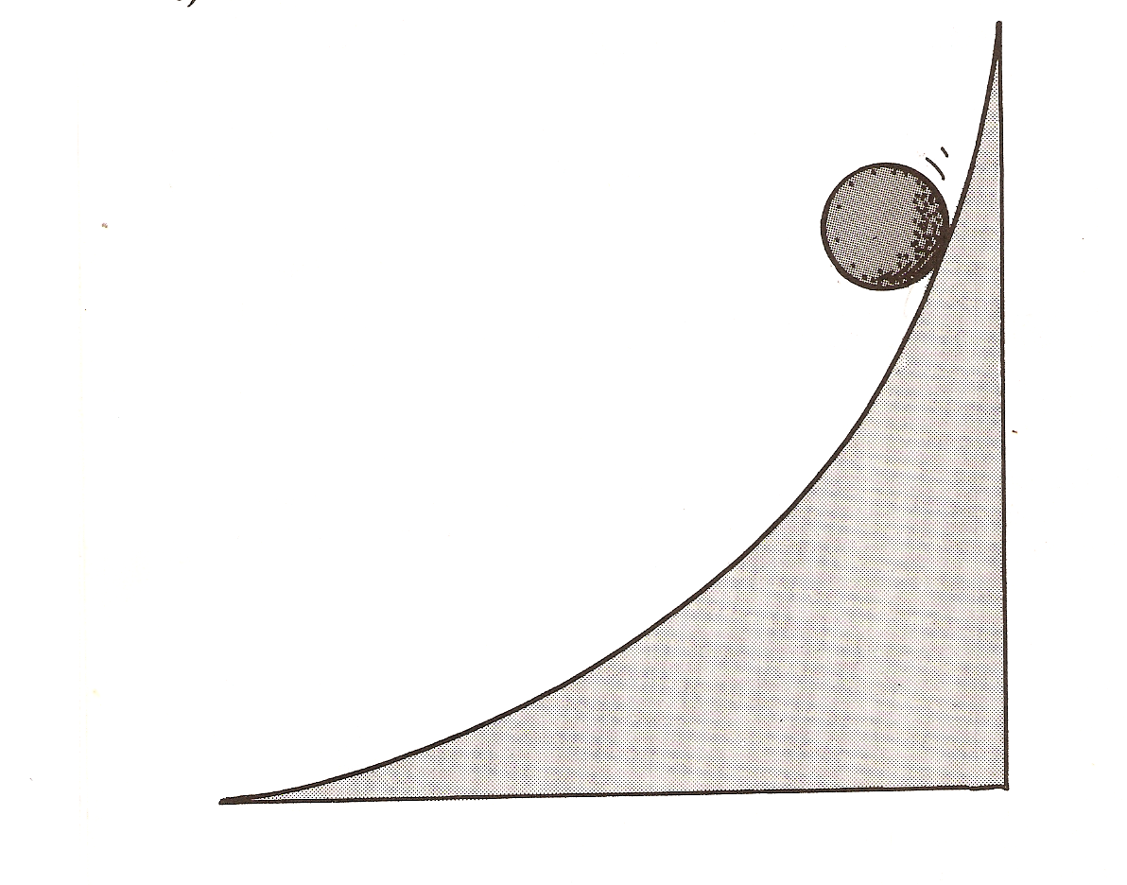Speed
     2. Velocity
     3. Acceleration

1. Consider a ball rolling down a hill as shown in the diagram at right. As it rolls down the hill, what happens to…
   1. Its speed
   2. Its acceleration

#### 

1. Jeanette watches a distant thunderstorm from her window. She sees the lightning and begins counting seconds until she hears the clap of thunder $t$ seconds later. Assuming the speed of sound in air to be $v$, write an expression how far away the thunderstorm is? Calculate the distance when $t=8.0 s$ and $v=340 m/s$.
2. Angelina, who is opening her new Broadway show, has some limo trouble in the city. With only 8 minutes until curtain time she hails a cab and they speed off to the theatre down a 1.00 km long one-way street at a speed of 25 m/s. At the end of the street the cab driver waits at a red light for 1.5 minutes and then turns north onto a 1700 m long traffic filled avenue at 10. m/s for the final leg of the Journey before he pulls up at the Theatre.
   1. **Draw a diagram** representing her journey
   2. **Decode/translate all the givens into equations**.
   3. Does Angelina make it to the Theatre on time? (**Justify your answer…**). A data table is a good way to set this problem up.
   4. What is the average speed of the limo over the course of this journey?

#### A three-toed sloth is the slowest moving land mammal. On the ground, the sloth moves at an average speed of $v_{sloth}=0.037m/s$, considerably slower than the giant tortoise, which walks at $v_{tortoise}=0.076 m/s$. After time $t=12 minutes$ of walking, how much farther would the tortoise have gone relative to the sloth?

#### **Draw a diagram** of this event with labels

#### **Write equations** for the distances traveled by the sloth and the tortoise

#### **Write an expression** for how much farther would the tortoise have gone relative to the sloth?

#### Now plug in the numbers and **calculate**

#### Mr. Aston went camping this summer in Yosemite. He looked up from his hotdog roasting to see an angry bear running straight at him. The bear was charging at a rate of 6.0 m/s. At the moment that he spotted the bear, a mere 26 meters away, Mr. Aston began running at a rate of 4.0 m/s toward his car. (we are going to ignore the reaction time for the purposes of this problem) This story has a happy ending – Mr. Aston reaches his car safely and eats his hotdog inside (no mustard, however)

#### A ball rolls down a hill. It starts at rest and travels 40.0 meters before reaching a speed of 20. 0 m/s.

* 1. **Derive** an expression for acceleration in terms of the variables given.
  2. Calculate the magnitude of acceleration.

#### A car going 50.0 m/s slows over the course of 30.0 seconds to a speed of 10.0 m/s.

#### **Derive** an expression for how far it traveled during the time that it was slowing down.

#### Calculate the distance.

#### Bernice waits impatiently at a red light. When it turns green, she floors it and accelerates at a rate of 3.5 m/s2 until she reaches her cruising speed of 25 m/s.

* 1. **Derive** an expression for how far she travels in the time it takes her to accelerate.
  2. Bonus: She is driving down Arastradero in front of Gunn High School…will she get a ticket for speeding? Justify your answer.

#### Skippy the skater first accelerates from 0.0 m/s to 5.0 m/s in 4.5 s, then continues at this constant speed for another 4.5 s. What is the total distance traveled by Skippy?

## Freely Falling Bodies

##### Refer to section 2.6, p. 43 - 47, in C&J Physics

In free-fall motion, the effect of air resistance on an objects’ fall/motion is neglected (as first approximation) and the motion is assumed to be influenced only by **acceleration due to gravity. Acceleration due to gravity -** denoted by the symbol ***g*** is a **vector pointing down (always) towards the center of the earth** with a magnitude of 9.8 m/ ${s^{}}^{2}$ (approximated to 10 m/ ${s^{}}^{2}$ for quick estimation in multiple choice questions)

1. Bernardo drops a ball from the top of a 50.0 meter tall building.
   1. Draw a diagram of this event with labels. Translate all the givens into labels on this diagram.
   2. How fast is the ball going when it hits the ground?
   3. How long did it take to fall?
2. Now Bernardo is mad. He throws his ball downward at 12 m/s from the top of his 50.0 meter tall building.
   1. Draw a diagram of this event with labels. Translate all the givens onto this diagram.
   2. What was its final velocity?
   3. How long did it take to hit the ground?
3. Down to his last and final ball, Bernardo decides to throw the ball upward at 12 m/s from the top of his 50.0-meter tall apartment building and watch it fall to the ground.
4. Draw a diagram of this event with labels. Translate all the givens onto this diagram.
5. What was its final velocity?
6. How long did it take to hit the ground?
7. The greatest height reported for a jump into an airbag is 99.4m by stuntman Dan Koko. In 1948 he jumped from rest from the top of the Vegas World Hotel and Casino. He struck the airbag at a speed of 39 m/s (88 mph).
   1. Draw a diagram.
   2. Derive an expression for the final velocity (velocity just before hitting the ground) in the absence of air resistance.
   3. Calculate the value of this final velocity.
8. An astronaut on a distant planet wants to determine the planet’s acceleration due to gravity. He drops a ball from a height of 2.5 meters and measures its time of fall to be exactly 1.15 seconds.
   1. Draw a diagram.
   2. Derive an expression for the acceleration (magnitude and direction) due to gravity on this planet?
   3. Calculate $g$ for the planet.
   4. Bonus! What is the name of the planet?
9. Two soccer players start from rest, 48 m apart. They run directly toward each other, both players accelerating. The first player's acceleration has a magnitude of 0.50 m/s2 . The second player's acceleration has a magnitude of 0.30 m/s2 .
10. Derive an expression for the amount of time that passes before the players collide.
11. Solve for that amount of time.
12. At the instant they collide, how far has the first player run? Remember to show all work!
13. An astronaut on a distant planet wants to determine its acceleration due to gravity. The astronaut throws a rock straight up with a velocity of +15 m/s and measures a time of 20.0s before the rock returns to his hand. What is the acceleration (magnitude and direction) due to gravity on this planet?
14. Two trains are accidentally put on the same track so that they are on a head-on collision course. Train-A is moving at 28 m/s and can decelerate at -4.0 m/s2. Train-B is moving at 30 m/s and can decelerate at -5.0 m/s2. When the trains are 190 meters apart they spot each other and immediately apply their brakes. Do they collide?
15. A ball is dropped from **rest** from the top of a cliff that is **24 m** high. From ground level, a second ball is thrown straight upward at the same instant that the first ball is dropped. The **initial speed** of the **second ball** is exactly the **same** as that with which the **first ball** eventually **hits the ground**. In the absence of air resistance, the motions of the balls are just the reverse of each other. Determine **how far below the top** of the cliff the balls cross paths. (HINT: Draw a picture. How fast is the first ball thrown up? Then set the displacements of the balls equal to each other and solve for time. What is the displacement of either ball at that time?).
16. A dynamite blast at a quarry launches a chunk of rock straight upward, and 2.0 s later it is rising at a speed of 15 m/s. Assuming air resistance has no effect on the rock, calculate its speed
    1. at launch and
    2. 5.0 s after launch
17. Recently, to relieve stress, Mr. O’Connell has taken up the hobby of hot air ballooning. One day he pilots a hot air balloon that is rising upward with a constant speed of 2.50 m/s. When the balloon is 6.00m above the ground, Mr. O’Connell accidentally drops a compass over the side of the balloon. How much time elapses before the compass hits the ground? Draw a diagram. Derive an expression for the time elapsed before the compass hits the ground. Calculate the time elapsed.

## Graphical Representations of Motion

##### Refer to section 2.7-2.8, p. 47 - 50, in C&J Physics

## 

General Graphing Questions:

1. How do you find the slope of a function? (this is a basic algebra question).
2. How do you find the area of a rectangle?
3. How do you find the area of a triangle?
4. Conceptually, what does a positive displacement mean? A negative displacement?
5. Conceptually, what does “constant velocity” mean?
6. Conceptually, what does a positive velocity mean (there are two things it can mean – think about both positive and negative displacement)?
7. Conceptually, what does a negative velocity mean (there are two things it can mean – think about both positive and negative displacement)?
8. Conceptually, what does “constant acceleration mean?”
9. Conceptually, what does a positive acceleration mean (there are two things it can mean…)?
10. Conceptually, what does a negative acceleration mean (there are two things it can mean…)?

Displacement vs. Time Graphs:

1. On a graph, how can you tell if the displacement is positive or negative?
2. On a graph, what does a flat line mean?
3. On a graph, what does a sloped, straight line mean?
4. On a graph, how can you tell if the velocity is positive or negative?
5. On a graph, how can you calculate a constant velocity of an object?
6. On a graph, how can you tell if the velocity is constant, or changing?
7. On a graph, how can you tell if there is acceleration or not?
8. On a curved line on a graph, is there just one slope? Can you find the slope of a curve for a given time?
9. How can you tell whether an object is speeding up or slowing down based on the curve of the graph?
10. On a graph, how can you tell if the acceleration is positive or negative?

Velocity vs. Time Graphs:

1. On a graph, how can you tell if the velocity is positive or negative?
2. On a graph, what does a flat line mean?
3. On a graph, what does a sloped, straight line mean?
4. On a graph, how can you tell if there is acceleration or not?
5. On a graph, how can you tell if the acceleration is positive or negative?
6. On a graph, how can you calculate a constant acceleration of an object?
7. On a graph, how can you calculate the displacement of an object (both positive and negative!)?
8. Will there ever be curved lines on a v. vs t graph?

Acceleration vs. Time Graphs

1. On a graph, what kind of line will there always be?
2. On a graph, how can you tell what the velocity of the object is?

**Graphical Analysis of Motion Practice!**

1. An ant crawls across the table. Its motion can be described by the graph at right. Describe the motion of the ant.



1. What is the velocity of the ant at 5 s?
2. What is the velocity of the ant at 12 s?
3. What is the velocity at 18 sec?
4. What is the acceleration at 7 sec?
5. Where is the ant located at 5 seconds?
6. Maggie drives her car in the Gunn Parking lot. The graph at right describes the car’s motion. Describe the motion of the car
7. What **distance** did the car travel from 0 s – 3 s?
8. What **distance** did the car travel from 3 s – 6 s?
9. What **distance** did the car travel from 6 s – 9 s
10. What **distance** did the car travel from 9 s – 12 s? In which direction
11. What is the **displacement** after 12 s?
12. What is the Total **distance** traveled after 12 s?
13. What is the acceleration of the car at 9 s?

**Draw the Graph**. On the axes provided, draw the motion described. Check the labels on the graphs to make sure that you are graphing the correct variable!

1. A package is dropped from an airplane. It accelerates until terminal velocity and then falls to the ground at that velocity.



1. A child swings back and forth on a swing. (Use the position of the swing when it is at rest for the zero displacement mark)



1. A car accelerates from rest until it smashes against a brick wall.



**Quick sketches......**

1. Sketch the displacement-time, velocity-time and acceleration-time for an object that is....
   1. at rest
   2. moving at a constant velocity
   3. accelerating at a constant rate
   4. slowing down at a constant rate to a point of stopping
2. Which graph would best depict the following scenario? A man starts at the origin, walks back slowly and steadily for 6 seconds. Then he stands still for 6 seconds, then walks forward steadily about twice as fast for 6 seconds. Note that these are ***velocity-time*** graphs.

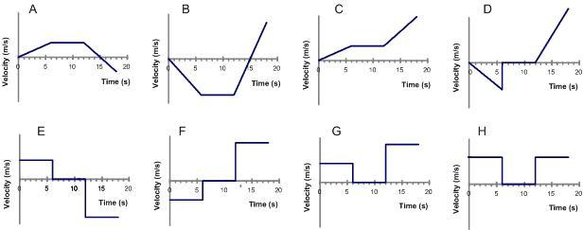

1. For the same scenario as # 2, which ***position-time*** graph best depicts the motion?

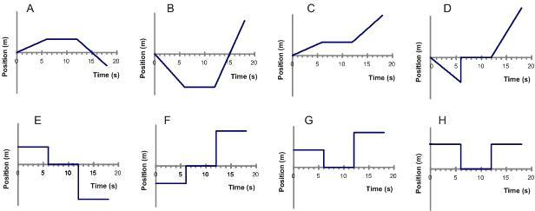

1. A car is moving forward and applying the break. Which ***position-time*** graph best depicts this motion?

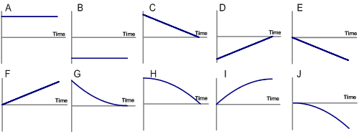

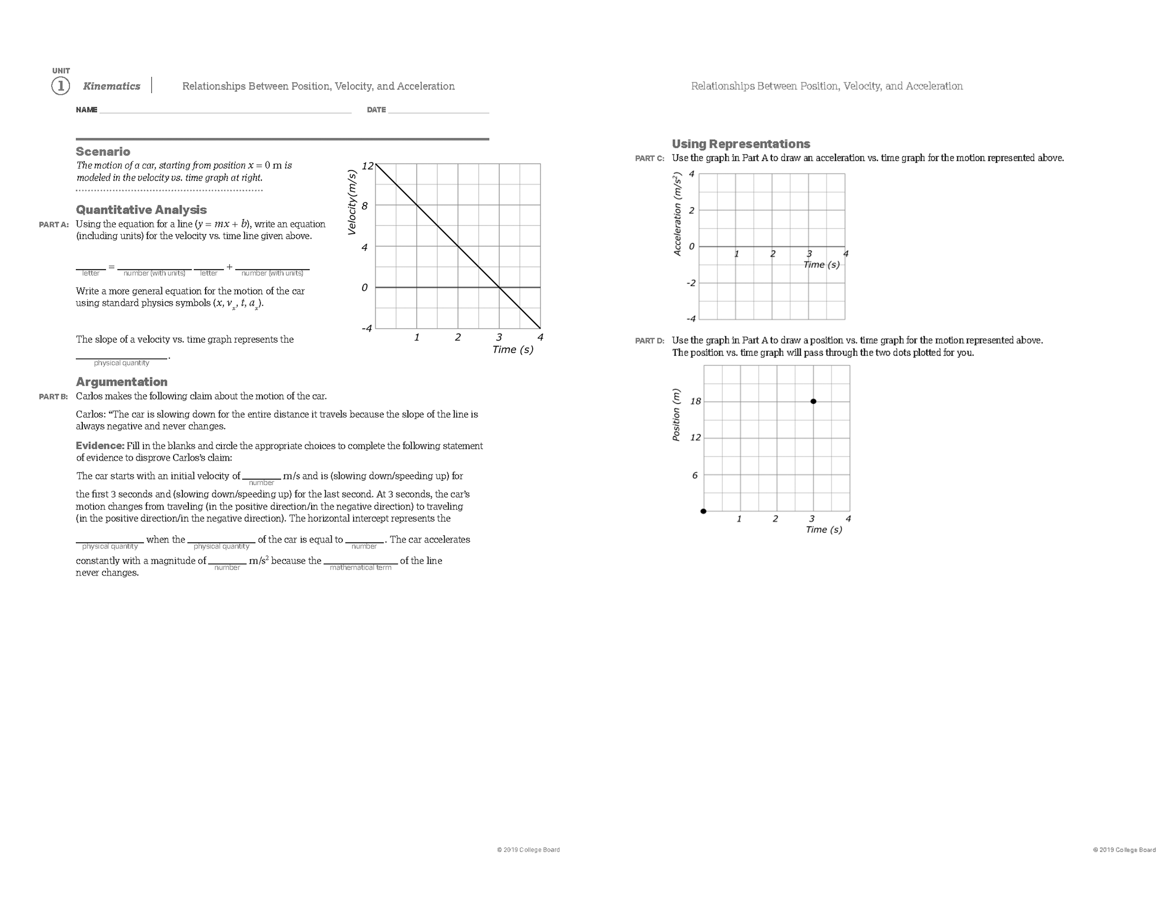

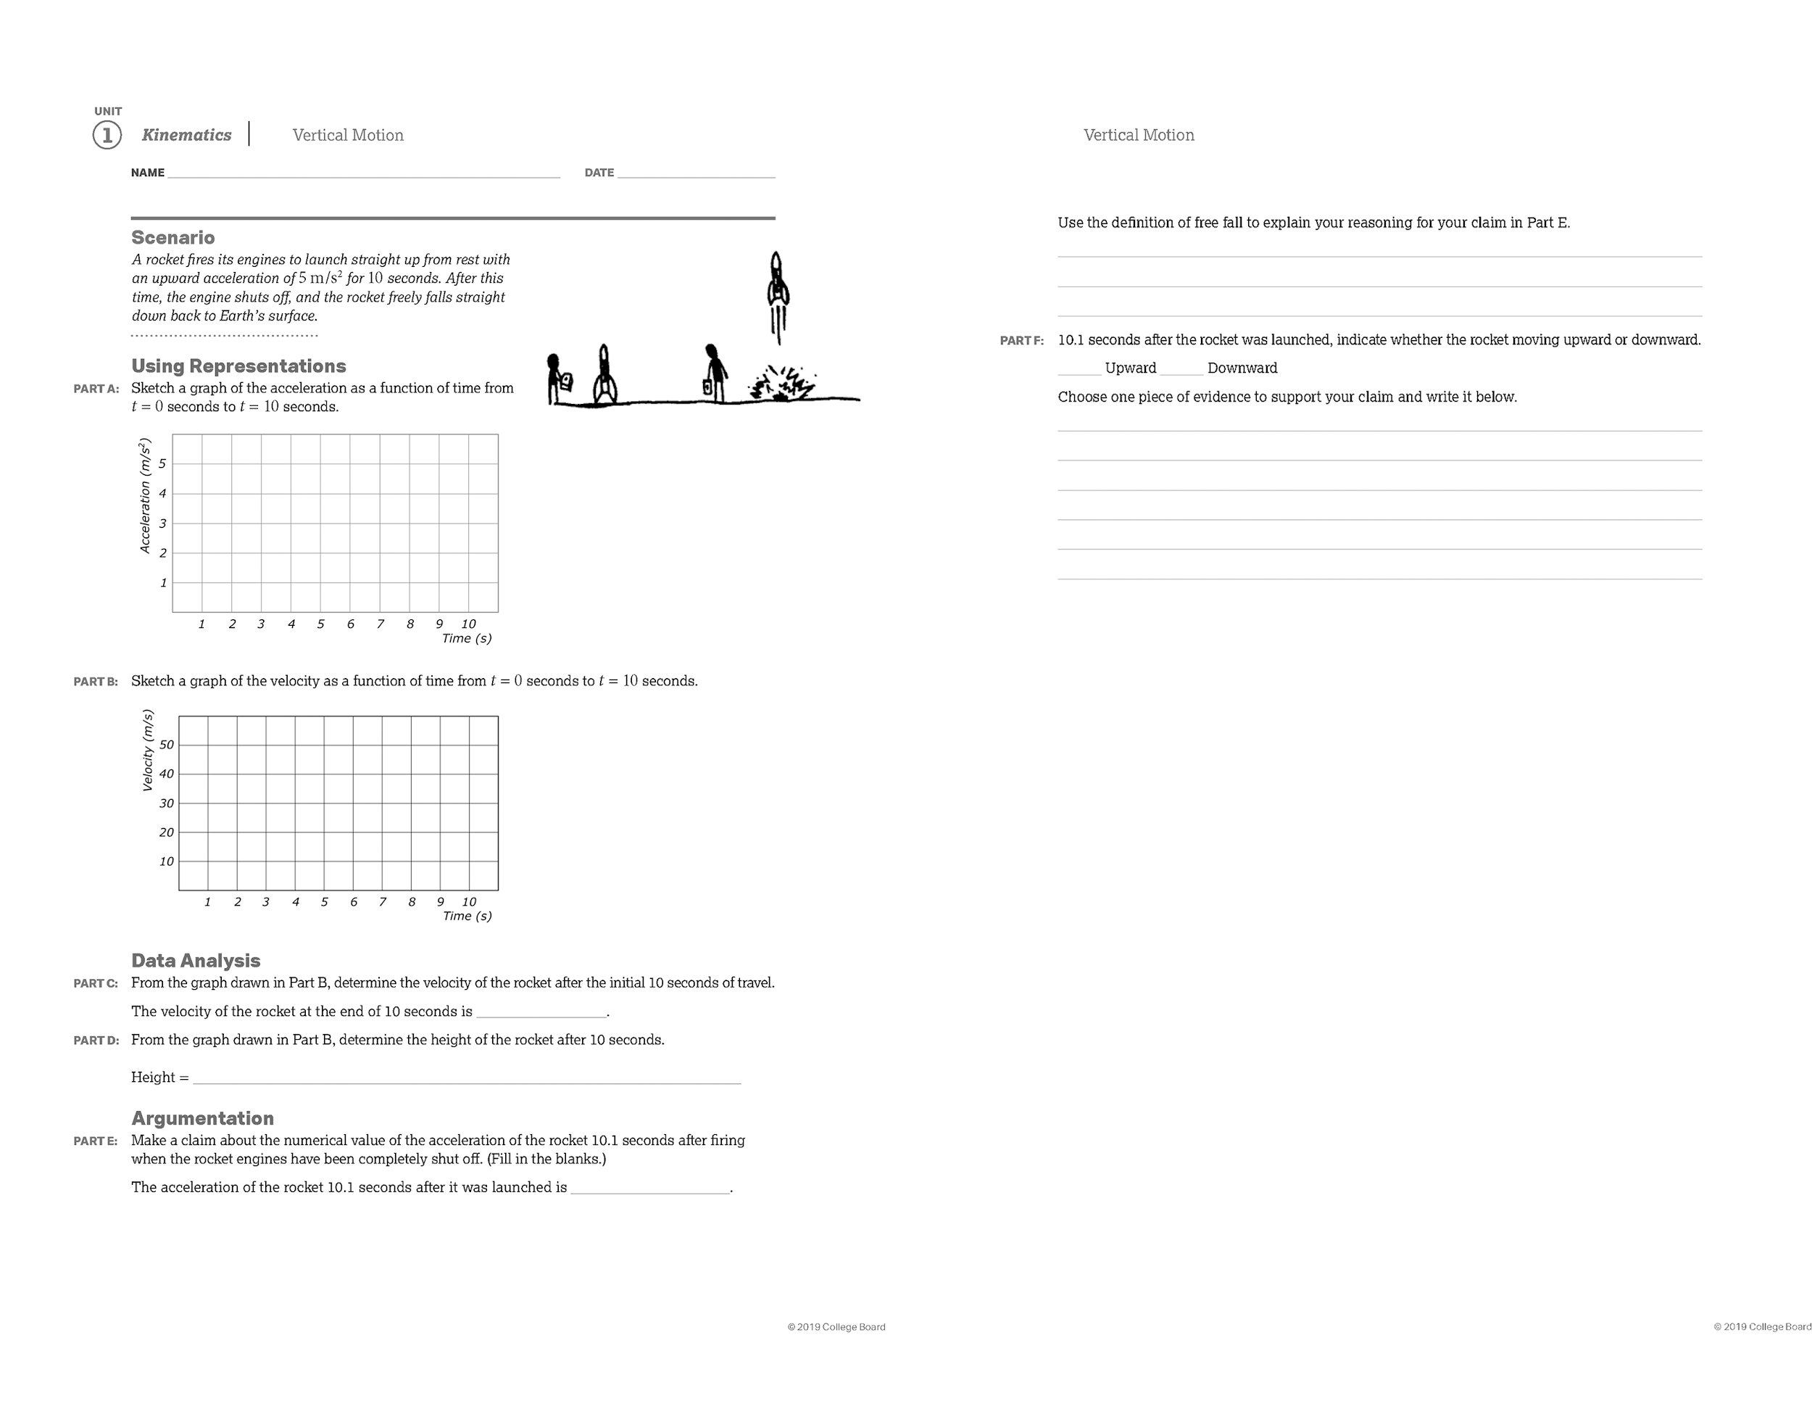

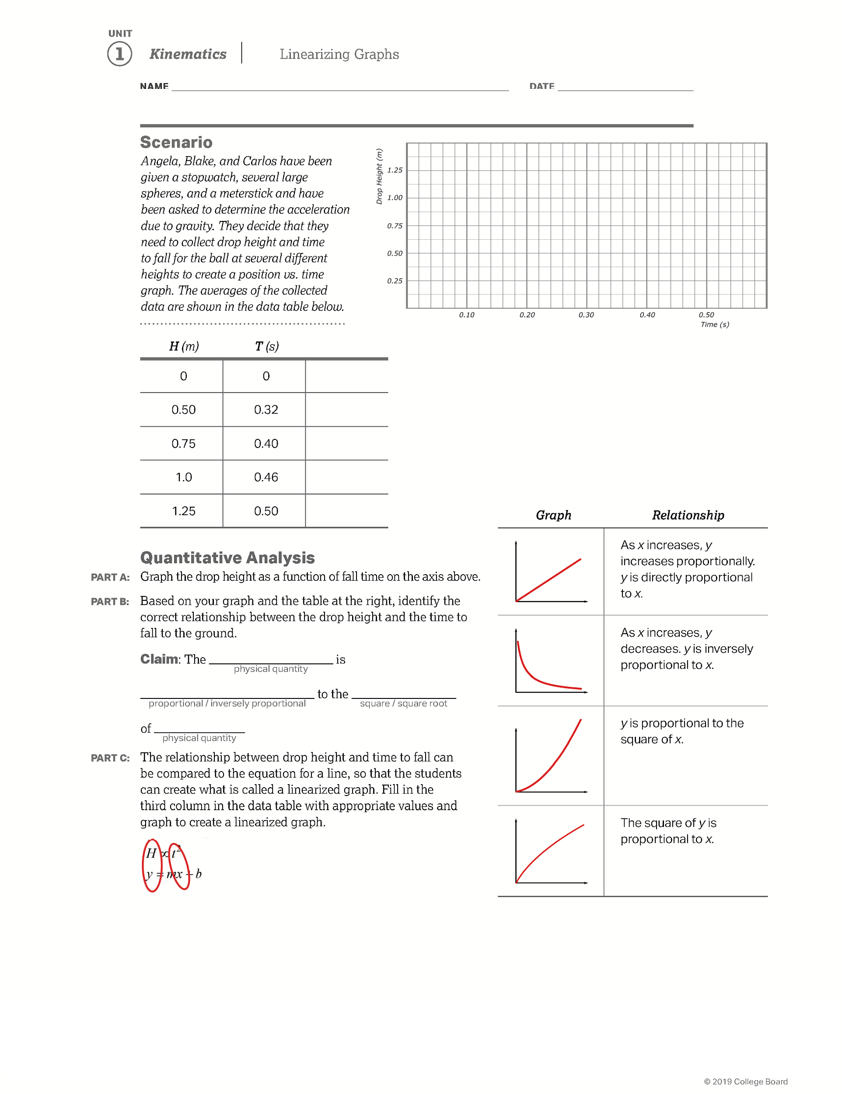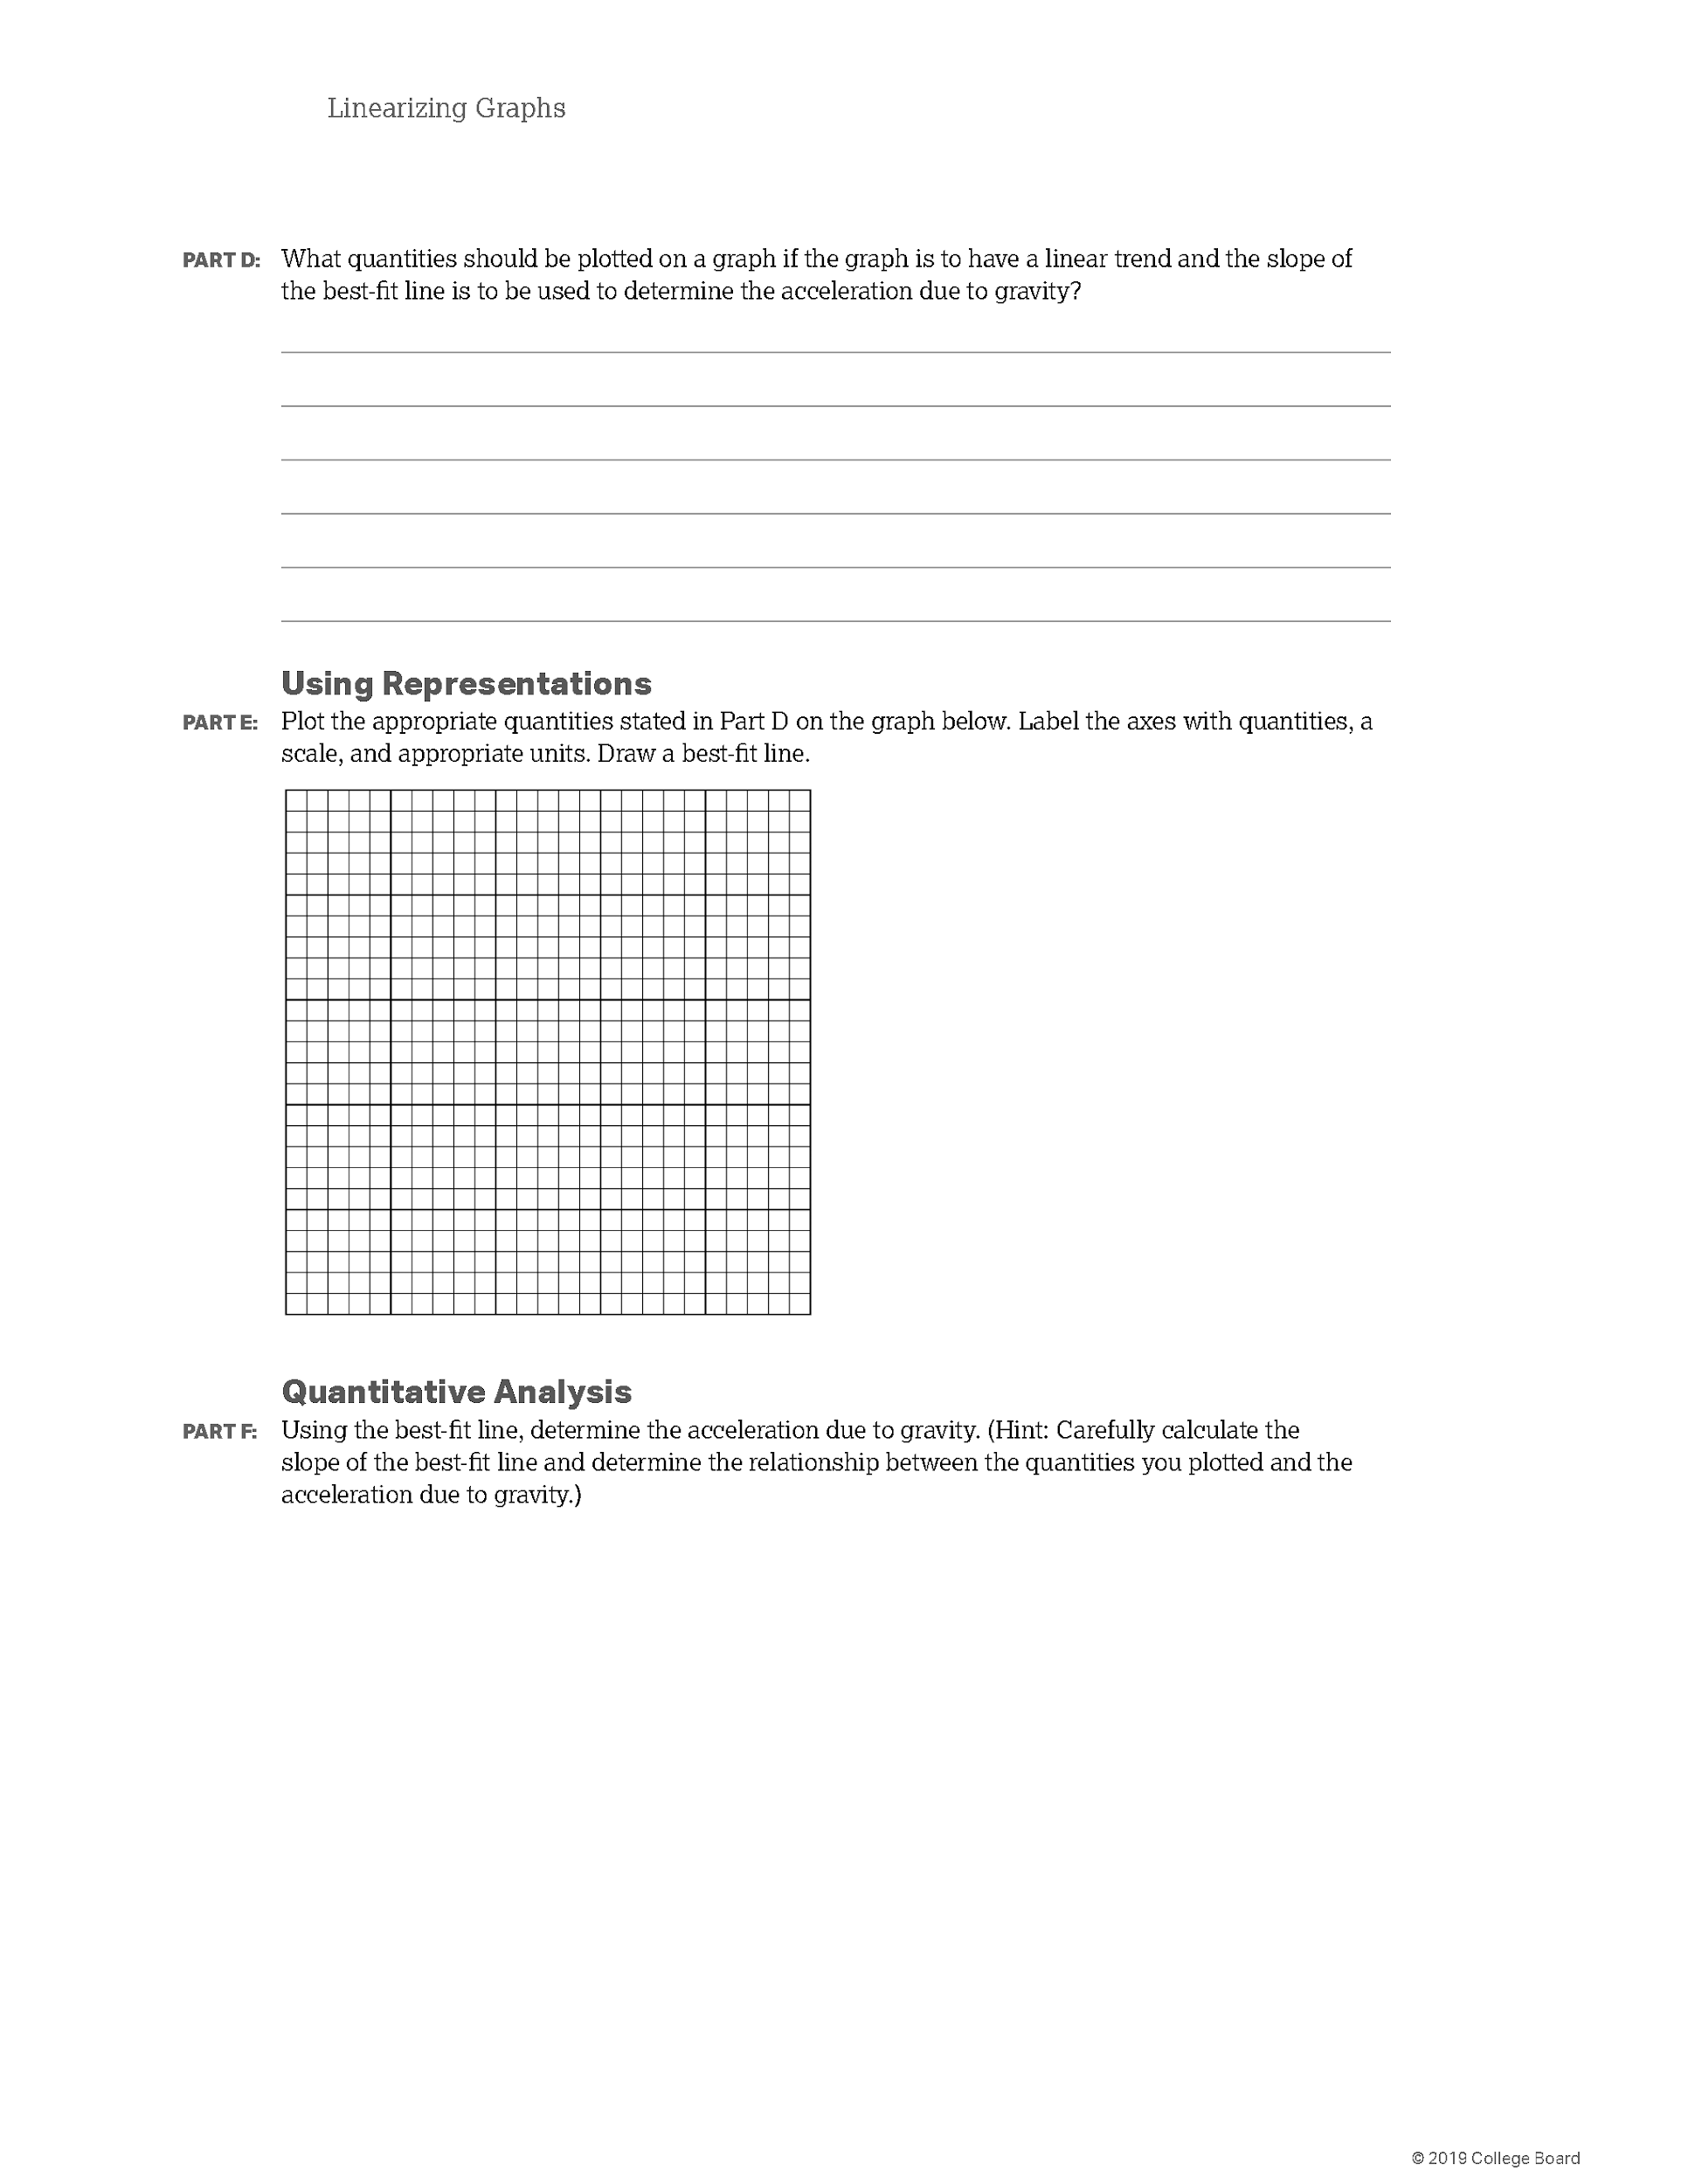



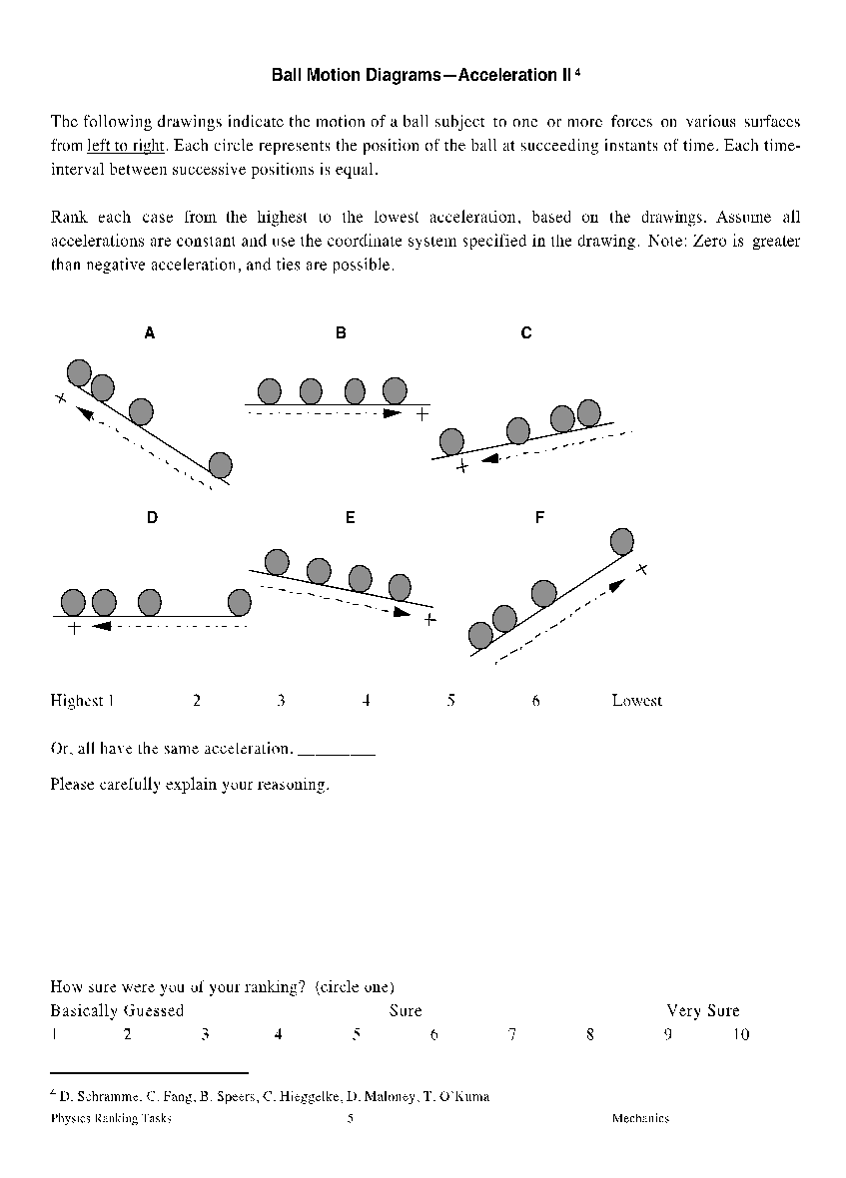



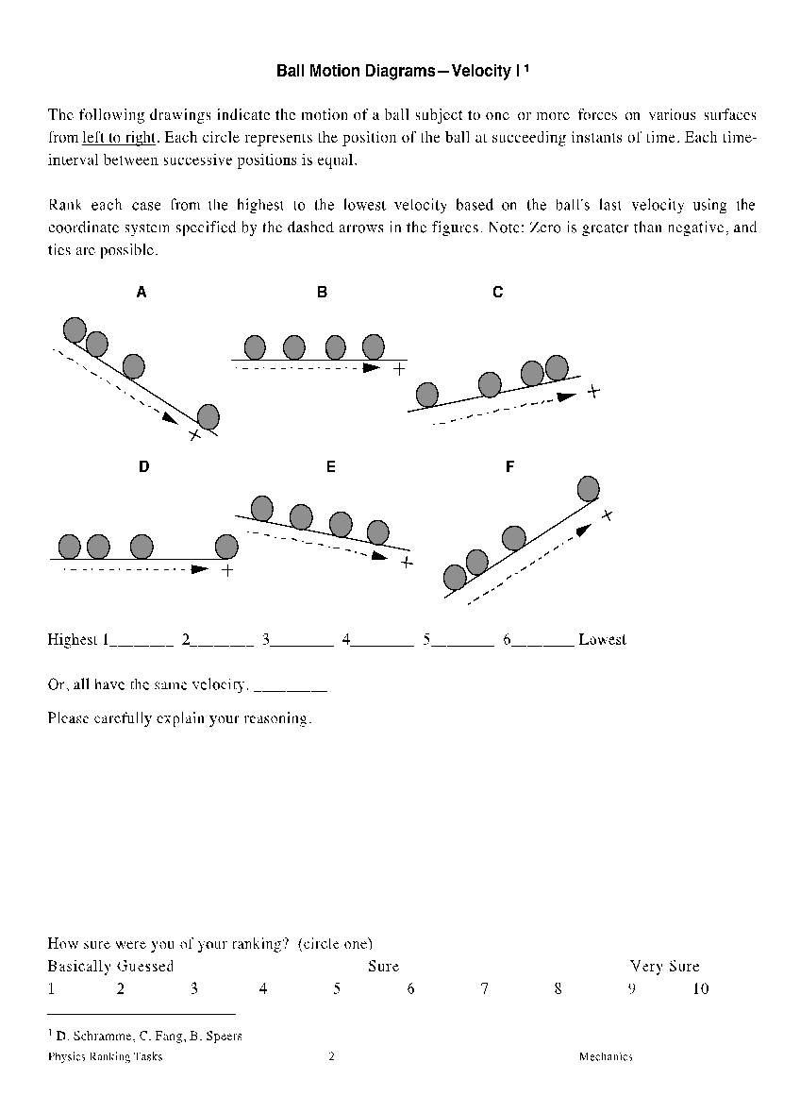

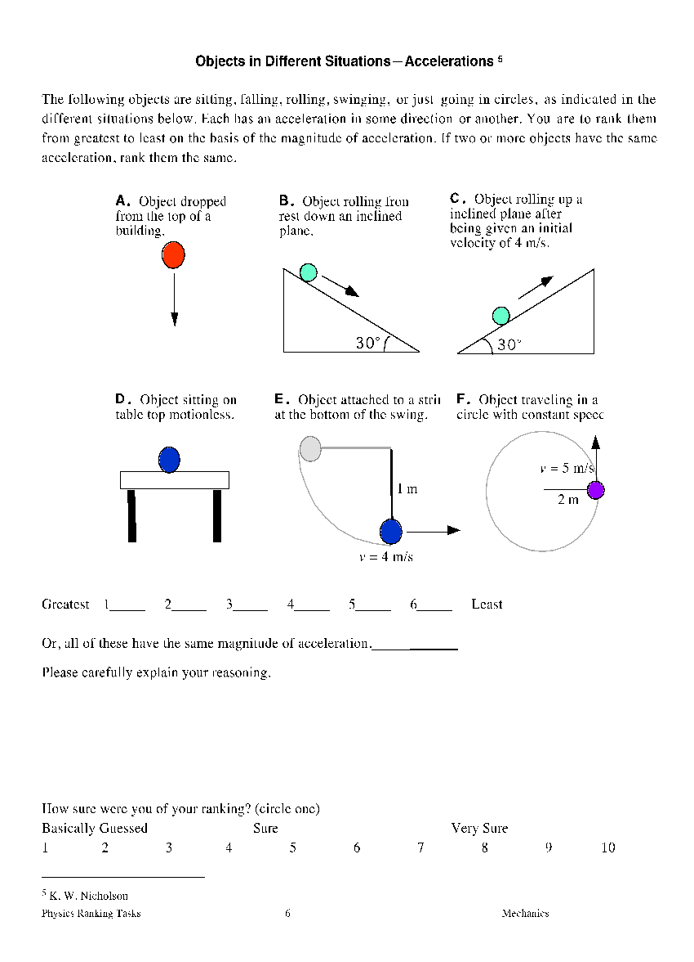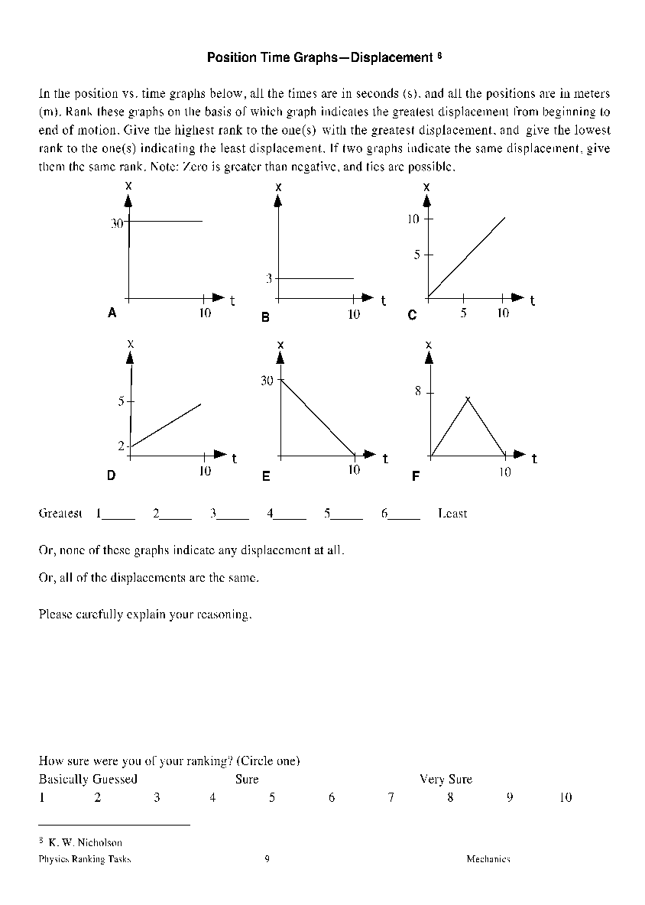

1. Steininger, Rosina. (2013). HOW CONCEPT CARTOONS STIMULATE SMALL- GROUP DISCOURSE IN UPPER SECONDARY CHEMISTRY CLASSES.
2. Cartoonist:Bisca, Paul Maximilian, Search ID:CX904876, Upload Date:16 Mar 2020
3. Multiple Representations of Knowledge: Mechanics & Energy